# Sustainable Fisheries 508 Compliance Information and Resources

## Important 508 and NOAA Library Related Sites and Information:

Library Section 508 Compliance Homepage: <https://noaa.libguides.com/Section508>

Library Webinar Trainings Homepage: <https://noaa.libguides.com/Section508/Brown-Bags>

* Word Document webinar: [Session recording](ftp://ftp.library.noaa.gov/BrownBags/FaganFry06212018-Word508.mp4),
* PDF Document webinar: [Session recording](ftp://ftp.library.noaa.gov/BrownBags/FaganFry04192018.mp4), [How-to-Manual (PDF)](ftp://ftp.library.noaa.gov/BrownBags/HowToManualSection508PDF.pdf)

## 508 Helpful Reminders

A. Documents less than 20 pages do not need a table of contents, therefore are not *required* to have tagged headings

B. Anything that is 1-3 pages, that you would like on the website, regardless of if it’s in the library, could/should be converted to HTML.

C. 508 compliance starts with your **Word Document**

a. In your Word Ribbon, use the appropriate Headings under styles (e.g. Heading 1, 2, Table Title, Figure Title)

b. Create tables with the table widget in word when possible. Tag your header row by placing your cursor in the first row, right clicking, select table properties. Shut of “break across pages”. Provide alt text for your table. Avoid using “merge cells”.

c. Alt tag your images. Right click on your image, select format picture, and then in the right hand ribbon, under layout and properties

d. Use your page and section breaks often! Do not hit enter-enter-enter-enter to get to the next page

e. Turn on your “characters” feature and delete extra spaces.

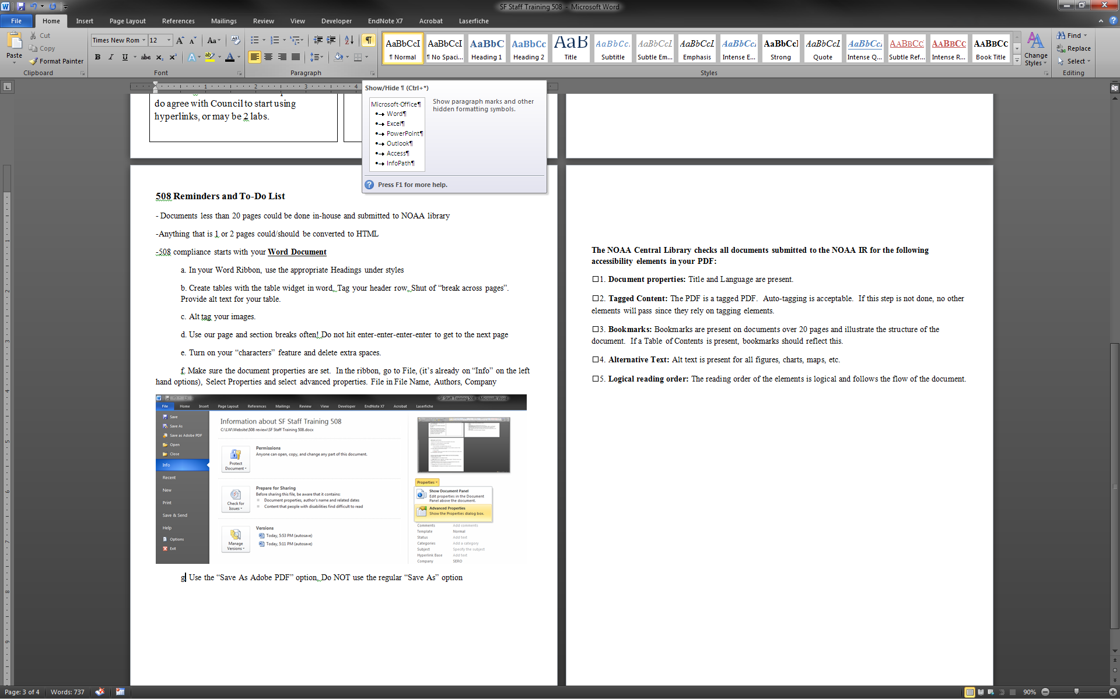

f. Make sure the document properties are set. In the ribbon, go to File, (it’s already on “Info” on the left hand options), Select Properties and select advanced properties. File in File Name, Authors, Company.

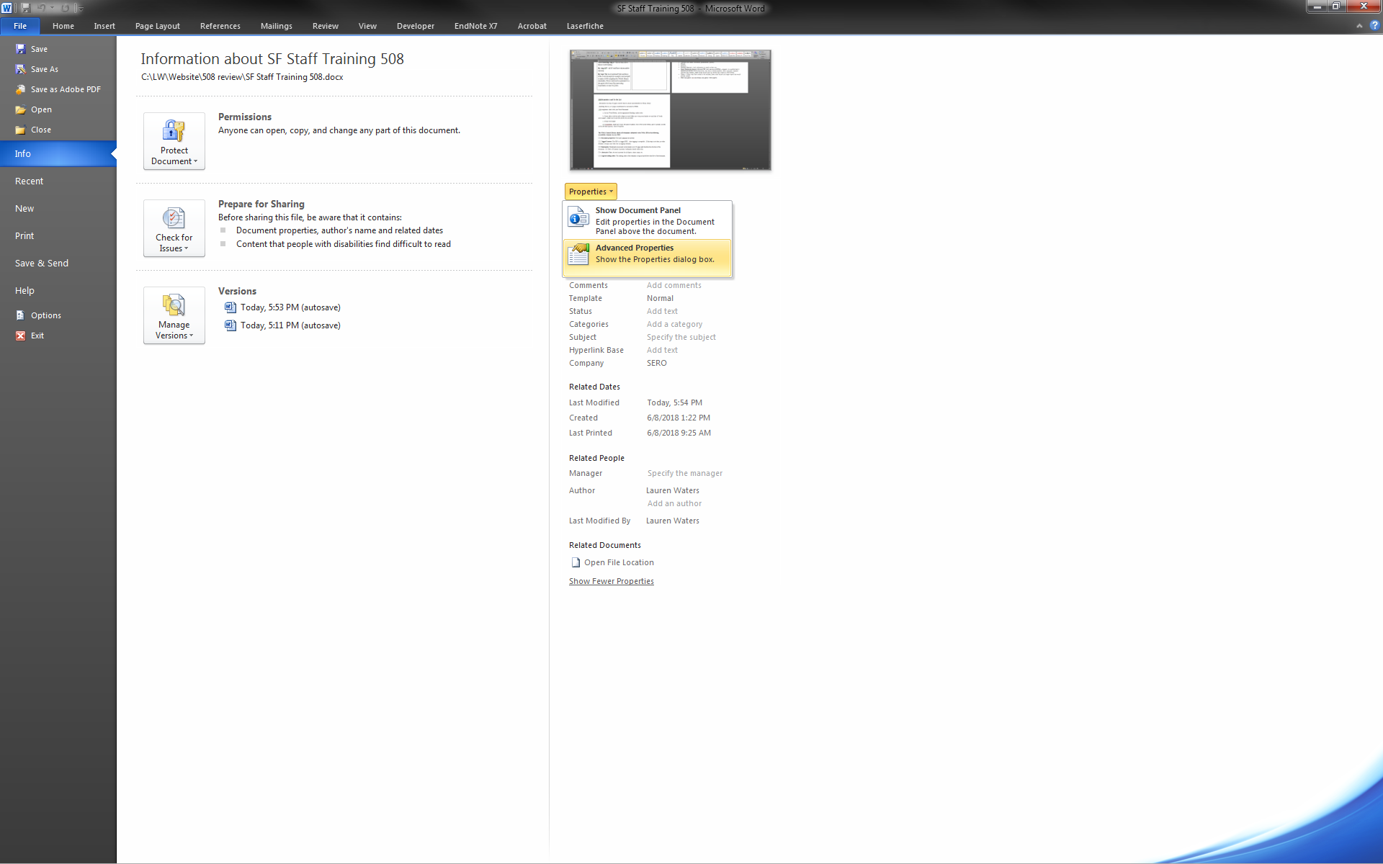

g.Use the “Save As Adobe PDF” option. Do NOT use the regular “Save As” option. Do not use PRINT as PDF

## IV. NOAA Central Library Basic Checklist for Compliance

**The NOAA Central Library checks all documents submitted to the NOAA IR for the following accessibility elements in your PDF (this will grow as time goes on):**

1. **Document properties:** Title and Language are present.

2. **Tagged Content:** The PDF is a tagged PDF. Auto-tagging is acceptable. If this step is not done, no other elements will pass since they rely on tagging elements.

3. **Bookmarks:** Bookmarks (headings) are present on documents over 20 pages and illustrate the structure of the document. If a Table of Contents is present, bookmarks should reflect this.

4. **Alternative Text:** Alt text is present for all figures, charts, maps, etc.

5. **Logical reading order:** The reading order of the elements is logical and follows the flow of the document.